BRIEF FOR THE LOGO
AND/OR CORPORATE IDENTITY CREATION

This brief will help us to do your task in the best way. Your clear and irrefragable answers will speed the work, so we find common language in order to achieve goal as quickly and efficiently as possible.
We ensure absolute confidentiality of the information you provide us with. Brief is not a technical task, it just helps us to understand your idea of the future corporate identity.
If you are at a loss with filling in the brief, please contact us in any way convenient for you. We will do it together.

- Your contact info
How can we get into touch with you for the further project discussion? Please indicate the most convenient ways for you to communicate.
Company name
Contact person
Telephone/Skype
Email

Date of completion ______________

2. Information about the company
What is your company profile? Please describe in plain language your focus area as if you communicate with customers.
Please describe strong points of your company. What distinguishes you from your competitors? What is your uniqueness?
Your company motto

3. Target audience of your company
Please tell us about the audience you work with. Are they individuals or corporate clients? What are their main geographical, age, social, behavioral traits?

4. What is the purpose of this logo and/or corporate identity creation?
What do you want to achieve by using the logo? Contact points and media. Where can consumer see your corporate identity the most frequently?
5. Impressions
What impressions would a consumer experience when looking at your logo image? What type of the brand do you want to get?

6. Form and content
Languages use
(Cyrillic, Latin, etc.)
Name
(for every language version)
What elements reflect the main point of your brand?
What images and ideas are unacceptable for your logo creation? Please give your reasons.
What KIND of the brand do you prefer? (discreet, evocative, romantic, charismatic, etc.)?

7. Logo type

What TYPE of the brand do you prefer? (Choose up to 3 and place a check mark):

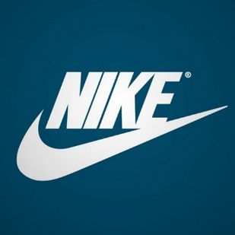 | 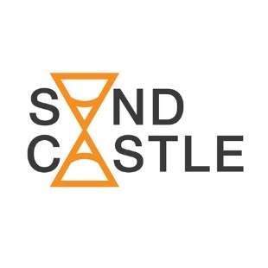 | 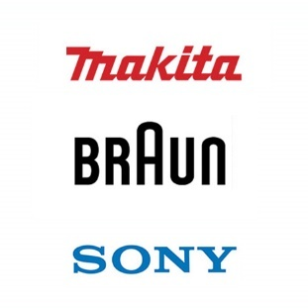 | 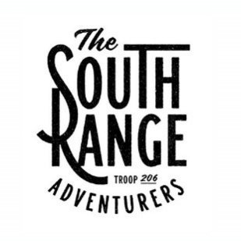
Combined:  mark + name pattern | Integrated:  name pattern includes the mark | Font | Compositional font
 |  | 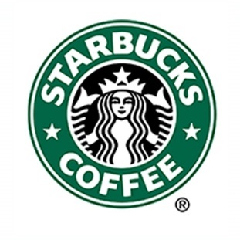 | 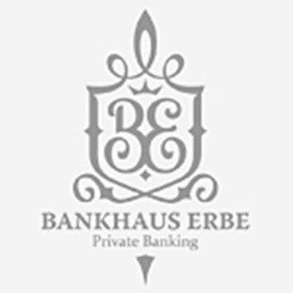
Character | Mark only | Emblem | National emblem
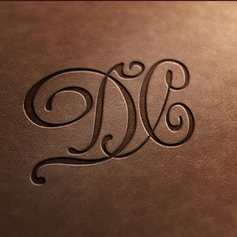 | 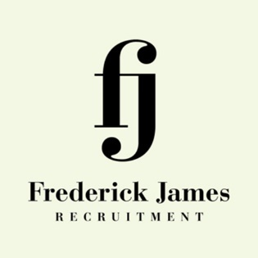 | 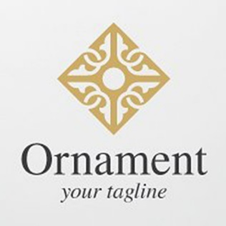
Monogram | Ligature | Ornamental pattern

8. Logo style

What style/ image of the logo do you prefer? (Choose up to 3 and place a check mark):

Form and counterform
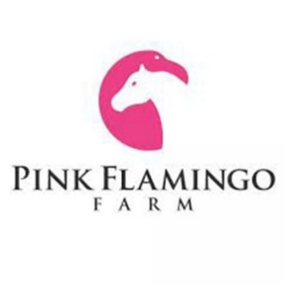 | 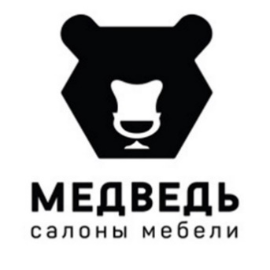 | 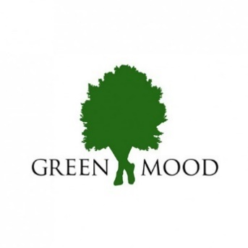 | 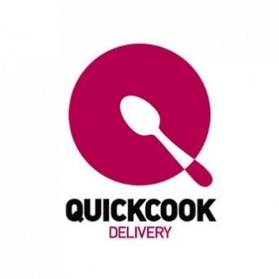

Allegory, metaphor
 | 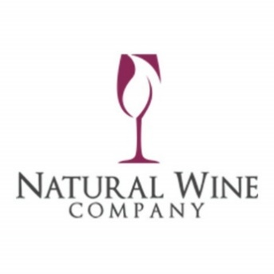 |  | 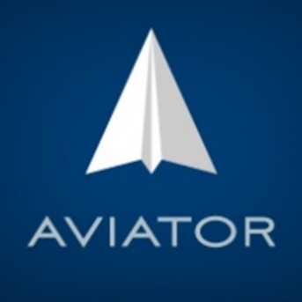

Calligraphy
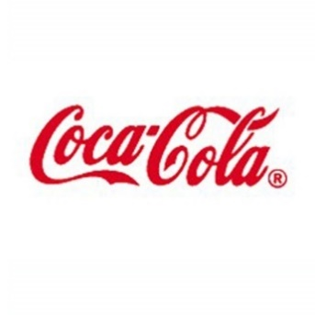 | 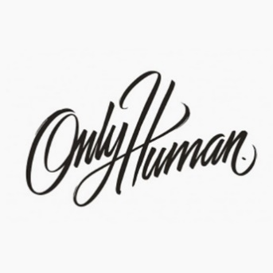 | 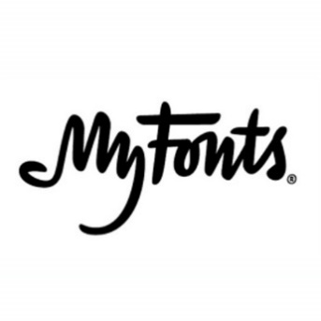 | 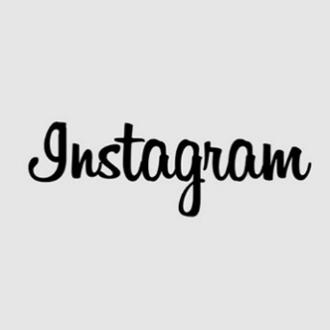

Size, photorealism
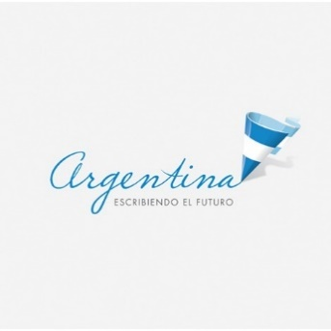 | 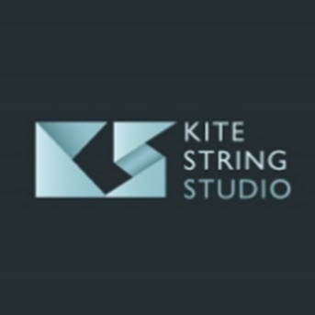 | 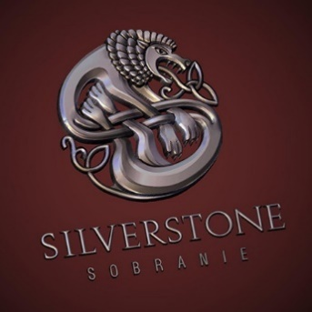 | 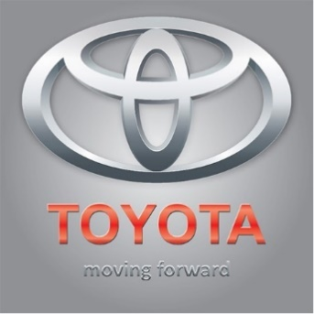

Plane figure
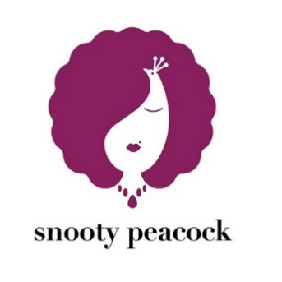 |  | 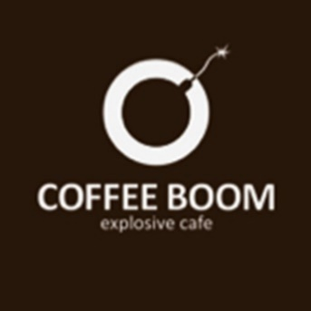 | 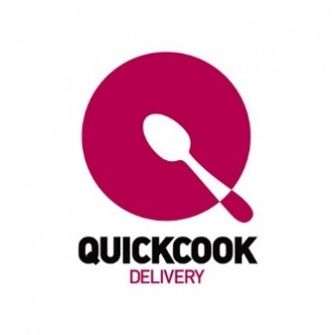

Majesty, aristocracy
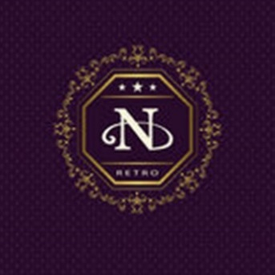 | 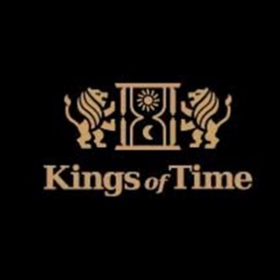 | 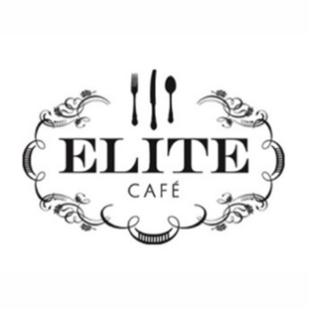 | 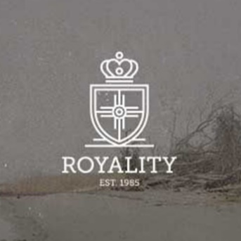

Typography
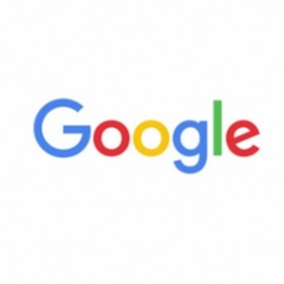 | 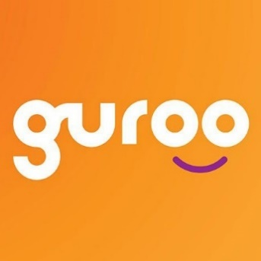 | 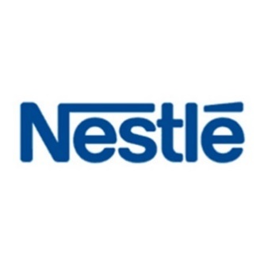 | 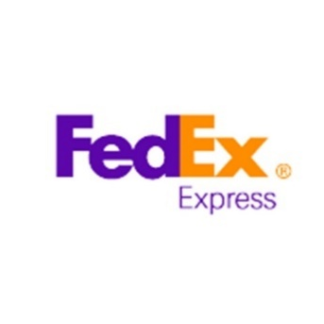

Humor
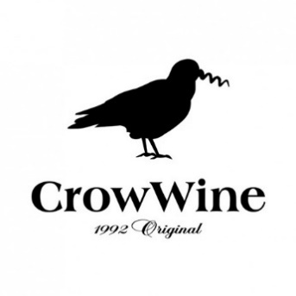 | 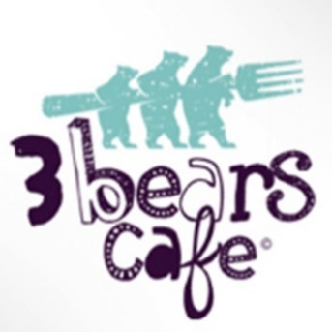 | 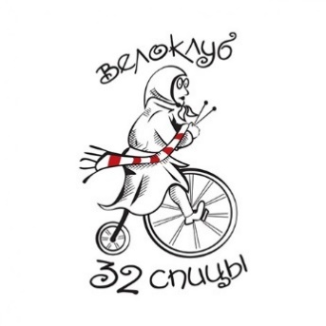 | 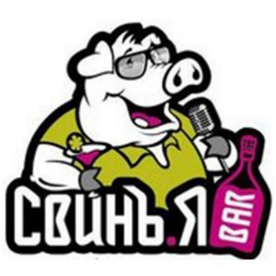

Gradients, transparences
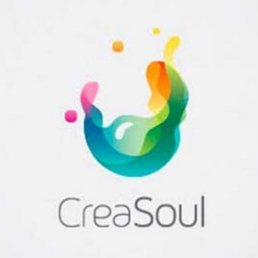 | 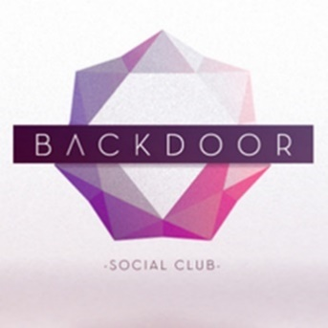 | 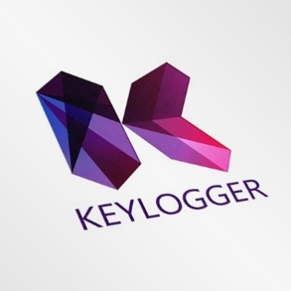 | 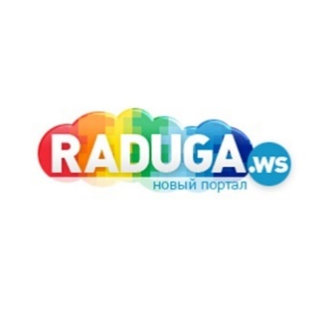

Drawing
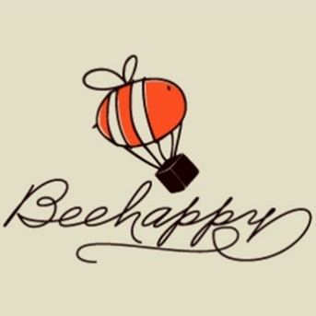 | 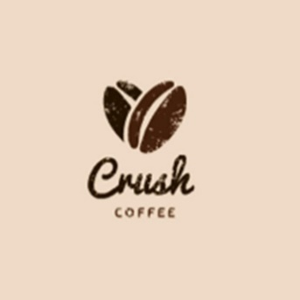 | 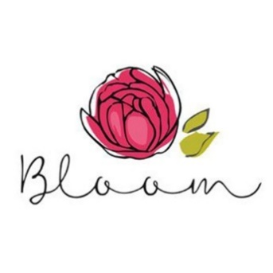 | 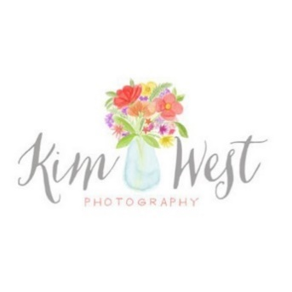

Abstraction
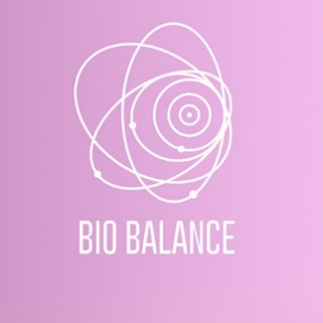 | 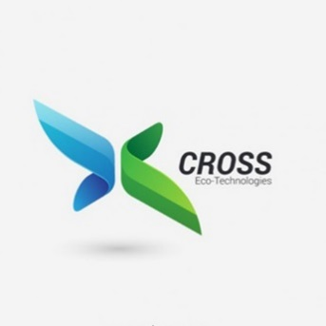 |  | 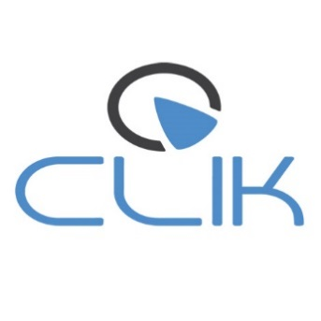

Childishness, intentional infantilism
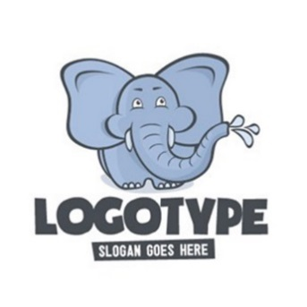 | 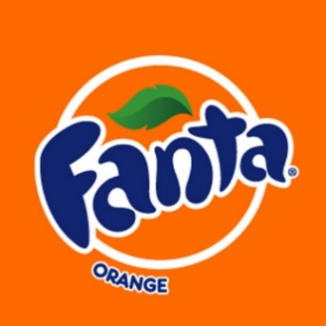 | 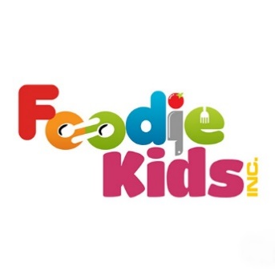

Nature
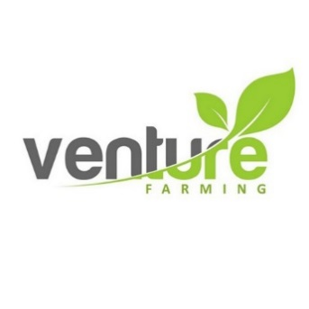 | 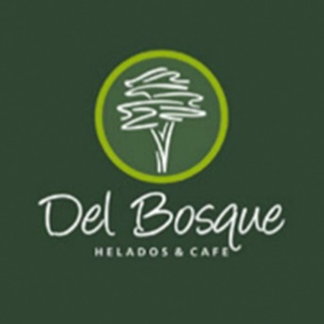 | 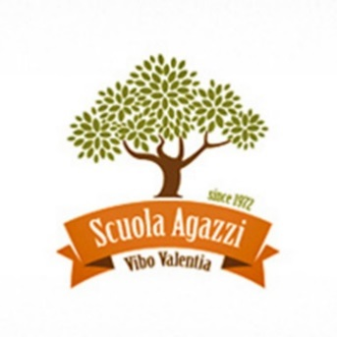

9. Color spectrum
What colors (their number) of the brand do you consider to be the most appropriate?

10. Examples
Please give examples of logos and other brands’ styles you consider to be successful in terms of desired image of the brand and give your reasons for it.
Please give examples of logos and other brands’ styles you consider to be unsuccessful in terms of desired image of the brand and give your reasons for it.

11. Corporate identity

If you need a corporate identity, what brand-name medias should be developed?

 | Visiting card (corporate or personal) |  | Badge
 | Form |  | Identity card
 | Fax form |  | Notebook
 | Euro envelope (DL), A4 (C4), A5 (C5) |  | Block cube
 | Documental case |  | Pencil/pen
 | PowerPoint presentation templates |  | Table flag
 | Templates for a technical, project and other documentation |  | Ashtray
 | CD/DVD cover |  | Cigar-lighter
 | Greeting card template |  | Cup / glass
 | Invitation Template |  | Overall (please point the type of it)
 | Sample leaflet /flyer |  | Motor transport (specify the brands of cars and special equipment)
 | Typical booklet |  | СStand
 | Modular grid for a print and outdoor advertising |  | Others (point – what exactly)

What type of a branding guide do you need?

Brand book (description of the marketing strategy + description of the visual communications and their standards as an example of various medias)

Guideline (description of the standards and working principles with a corporate identity)

Nothing is needed

12. Your comments,questions, wishes

Thank you for being so serious about filling out this questionnaire. Attach additional files and documents, if necessary.

We will contact you to clarify the details and start our fruitful cooperation.

Thank you for contacting us!

